Project Report
CMOS Standard Cell Library: Transistor-Level Design, Truth-Table Verification and Propagation Delay of NOT, NAND, AND, NOR, OR and XOR Gates in Cadence Virtuoso
Tools: Cadence Virtuoso Schematic XL | ADE L with Spectre | gpdk090 process design kit

Abstract
This project builds a small CMOS standard cell library of six logic cells (NOT, NAND, AND, NOR, OR and XOR) at the transistor level in Cadence Virtuoso using the gpdk090 technology library. For every cell, a transistor-level schematic and a schematic symbol were created, a test bench with pulse sources was built, the truth table was checked against a Spectre transient simulation run from ADE L, and the propagation delay was read with the waveform calculator. All six cells use the same device sizes (PMOS 720 nm, NMOS 240 nm, L = 100 nm), so the cells differ only in topology, transistor count and logic depth, which grow from 2 transistors for the inverter to 22 for the XOR gate. The simulated waveforms confirmed the functions of all six gates for every input combination. The final XOR gate is assembled from the library NOT, AND and OR cells; an earlier flat 22-transistor version gave a wrong output for (A, B) = (0, 0) and was replaced. The measured average propagation delays are 19.15 ps (NOT), 25.8 ps (AND), 31.45 ps (NAND), 51.9 ps (NOR), 54.0 ps (OR) and 89.3 ps (XOR); a few of the individual readouts still fail simple consistency checks and are flagged for re-measurement.
Keywords- CMOS standard cell, NOT, NAND, AND, NOR, OR, XOR, Cadence Virtuoso, ADE L, Spectre, gpdk090, truth table, transient simulation, propagation delay.

1. Motivation

1.1 Why this project was chosen
Every digital chip, from a simple counter to a processor, is assembled from a standard cell library: a collection of small, pre-designed logic cells whose schematics, layouts and timing behaviour have been verified once and are then reused thousands of times by synthesis and place-and-route tools. Designing a few of these cells by hand is the most direct way to understand what the library actually contains and how each cell is made. NOT, NAND and NOR are the basic complementary CMOS cells, AND and OR are their non-inverting counterparts, and XOR is a first example of a composite cell built from several smaller ones. Together they form a compact but representative library, and NAND and NOR alone are already enough to build any combinational function.

1.2 Problem and concepts addressed
The project addresses four connected questions that appear in every cell design:
- Function: how a Boolean function is mapped onto a pull-up PMOS network and a complementary pull-down NMOS network, so that exactly one network conducts for every static input combination.
- Non-inverting logic: why a single complementary CMOS stage can only produce an inverting function, so that AND and OR need a second (inverter) stage and XOR needs a multi-stage cascade.
- Cost of structure: how series transistor stacks, transistor count and logic depth affect the area and the speed of a cell.
- Characterisation: how a cell is verified (truth table by transient simulation) and timed (propagation delay), since these are the two things a library must guarantee for every cell.

1.3 Project objectives
- To design the transistor-level schematic and symbol of the NOT, NAND, AND, NOR, OR and XOR gates in Virtuoso using the gpdk090 library.
- To verify the truth table of every gate with a Spectre transient simulation in ADE L.
- To measure the propagation delay of each gate and compare the six cells.
- To compare the schematics, test benches, waveforms and results of all six experiments and draw conclusions about the cost of each topology.

2. Methodology

2.1 Design approach
Every cell uses static complementary CMOS. The PMOS pull-up network and the NMOS pull-down network are duals of each other, so for any static input combination one network is ON and the other is OFF. This gives rail-to-rail outputs and, ideally, zero static power. The topology of each cell is summarised below.
- NOT: one PMOS (pull-up) and one NMOS (pull-down) with common gate and common drain.
- NAND: two parallel PMOS pull-up transistors and two series NMOS pull-down transistors (NMOS stack).
- NOR: two series PMOS pull-up transistors (PMOS stack) and two parallel NMOS pull-down transistors.
- AND: a NAND stage followed by an inverter stage (3 PMOS + 3 NMOS).
- OR: a NOR stage followed by an inverter stage (3 PMOS + 3 NMOS).
- XOR: built hierarchically from the library cells to implement Y = A·B′ + A′·B: two NOT cells produce A′ and B′, two AND cells form A·B′ and A′·B, and one OR cell combines them (11 PMOS + 11 NMOS, eight CMOS stages in total).
To keep the comparison fair, the same device dimensions were used in all six cells, as listed in Table-2.1. The PMOS width is three times the NMOS width to compensate for the lower hole mobility. The series transistors in the NAND and NOR stacks were deliberately not widened, so the effect of stacking remains visible in the results.
Device | Width (W) | Length (L) | Used in
PMOS (gpdk090_pmos1v) | 720 nm | 100 nm | All six gates
NMOS (gpdk090_nmos1v) | 240 nm | 100 nm | All six gates
Table-2.1. Device parameters used for every PMOS and NMOS transistor in the library.

2.2 Tools and technology
- Cadence Virtuoso Schematic XL (schematic and symbol editing).
- Virtuoso Analog Design Environment (ADE L) with the Spectre circuit simulator.
- Virtuoso Visualization and Analysis XL (waveform viewer and calculator).
- gpdk090 generic process design kit: gpdk090_nmos1v and gpdk090_pmos1v devices.
- analogLib: vpulse (input sources), vdc (1.8 V supply) and gnd.
- Linux workstation running the Cadence environment inside a virtual machine.

2.3 Step-by-step flow
The same design flow was repeated for each of the six gates:
- Create a design library for the gate and attach it to the gpdk090 technology library.
- Place the PMOS and NMOS instances in Schematic XL, set W and L in the Add Instance window, and wire the pull-up and pull-down networks with the A/B input pins, the output pin and the VDD/VSS pins.
- Check and save the schematic without errors.
- Generate the symbol with Create → Cellview → From Cellview and replace the default rectangle by the standard gate shape (inverter, NAND, AND, NOR, OR or XOR).
- Build the test bench (inverter_test): instantiate the symbol, add the vpulse sources, the 1.8 V vdc supply and ground, and name the nets with Create → Wire Name.
- Open ADE L, select Spectre, add the gpdk090 model library, configure the transient analysis and select the input and output nets for plotting.
- Run Simulation → Netlist and Run, plot the waveforms and compare the output with the truth table interval by interval.
- Measure the propagation delay with the waveform calculator (Section 2.5) and compare the six gates.

1. Library (gpdk090) | 2. Schematic + sizing | 3. Symbol | 4. Test bench | 5. ADE L / Spectre | 6. Truth-table check | 7. Delay measurement
Figure-2.1. Design and verification flow used for every gate in the library.

2.4 Test bench and stimulus
The NOT gate was driven by a single pulse source (0 to 1.8 V, 20 ns period, 10 ns pulse width; its netlist specifies no rise or fall time, so its edge rate differs from the 50 ps edges used for the other five gates) and simulated with a transient analysis plus a DC sweep of V1:dc from 0 V to 1.8 V in 36 mV steps (as recorded in its Spectre log) to obtain the voltage transfer characteristic (VTC). The transient run is configured to 200 ns, and the NOT screenshot shows the first 100 ns. The five two-input gates were driven by two independent pulse sources: V1 on input A (20 ns period, 10 ns pulse width) and V2 on input B (40 ns period, 20 ns pulse width), both from 0 V to 1.8 V with 50 ps edges, and simulated with a 200 ns transient analysis. B toggles at half the frequency of A, so the inputs repeat the four-state sequence of Table-2.2 every 40 ns. The first four intervals are the ones read from the waveforms. In the netlist the pulse sources have no delay, so both inputs are 0 V at t = 0 and rise within 50 ps; every gate therefore starts at its (0,0) output level and then moves to the (1,1) level.
Interval (ns) | A | B | Event at the start of the interval
0 – 10 | 1 | 1 | Start of simulation
10 – 20 | 0 | 1 | A falls (single-input change)
20 – 30 | 1 | 0 | A has finished rising when B starts to fall, so (1,1) is present for about 50 ps
30 – 40 | 0 | 0 | A falls (single-input change)
40 – 50 | 1 | 1 | A and B rise together; the pattern repeats
Table-2.2. Input sequence applied to the two-input gates (repeats every 40 ns).
The Spectre logs of the six runs show identical simulator settings, listed in Table-2.3. The maximum step of 4 ns and the trapezoidal-only integration method matter for the delay measurement and for the spikes discussed in Section 4.3.
Setting (from the Spectre log) | Value
Simulator | Spectre 12.1.0 (MMSIM121), 32-bit; gpdk090 v4.6 models
Transient analysis | start 0 s, stop 200 ns, step 200 ps, maxstep 4 ns
Integration method / accuracy | method = traponly, errpreset = moderate, reltol = 1e-3
Temperature | 27 °C
Netlist elements | bsim3v3 MOS devices and 2 or 3 voltage sources (see Table-4.6)
Table-2.3. Simulation settings recorded in the Spectre log files.

2.5 Propagation delay measurement method
Propagation delay is measured between the 50 % points of the input and output edges, with VDD = 1.8 V so that the 50 % level is 0.9 V. The high-to-low delay tpHL is taken from the input edge to the falling output edge and the low-to-high delay tpLH to the rising output edge; the average gate delay is tp = (tpHL + tpLH) / 2. In the calculator of Virtuoso Visualization and Analysis XL this is done with the delay() function, for example:
delay(?wf1 v("/A") ?value1 0.9 ?edge1 "falling" ?nth1 1 ?wf2 v("/Output") ?value2 0.9 ?edge2 "rising" ?nth2 1)
The delay values in Table-4.5 are calculator readouts supplied for this project. The edge pair is documented only for the AND gate, by the markers in Figure-3.15: tpHL was read at the 10 ns event (A falls, output falls) and tpLH at the 40 ns event (B rises while A also rises, output rises). In that figure the input markers sit at about 0.9 V, but the output markers sit at 0.67 V and 0.79 V, so the output times are those of the nearest simulated points rather than exact 50 % crossings; the true tpHL is therefore slightly smaller and the true tpLH slightly larger than the marker difference. For a repeatable measurement only one input should change (the 10 ns and 30 ns events of Table-2.2 are single-input changes; the 20 ns event passes briefly through (1,1) and the 40 ns event switches both inputs together), and the edge pair should be stated for every gate. The Spectre runs also use a maximum time step of 4 ns, which is coarse compared with the 50 ps edges; for confirmation the transient maximum step should be reduced to about 10 ps. None of the test benches in this project contains an explicit output load capacitor, so the delays are intrinsic delays only.

3. Relevant Window Screenshots
This section collects the Virtuoso windows captured during the six experiments. Each gate is shown with its transistor-level schematic, its symbol, its test bench and its simulated waveforms. The device and source parameter windows are identical for the whole library and are shown once.

3.1 Device and source parameter windows
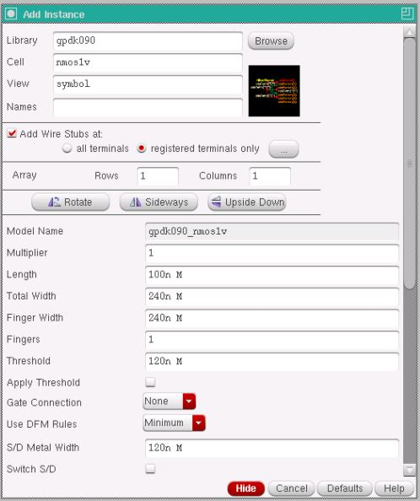
Figure-3.1. Add Instance window showing the transistor size set for the NMOS devices (Total Width = 240n, Length = 100n). The PMOS devices were set the same way with a total width of 720n.
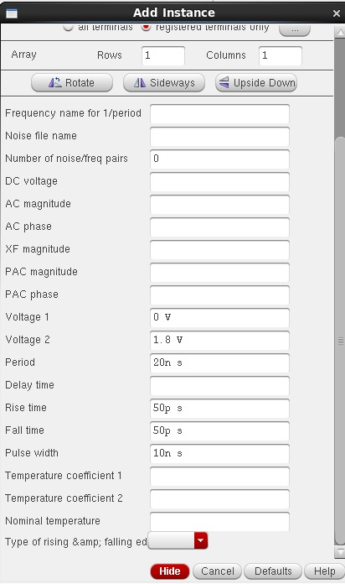  Figure-3.2. Pulse source V1 (input A): Voltage 1 = 0 V, Voltage 2 = 1.8 V, period = 20 ns, pulse width = 10 ns. | 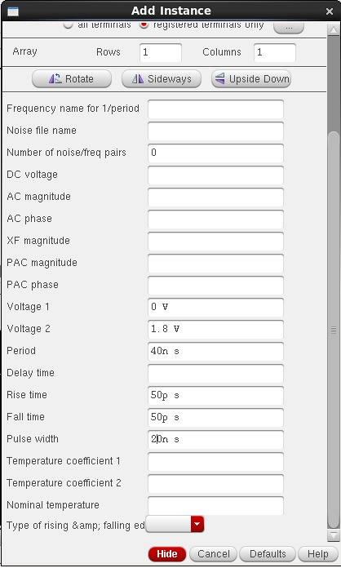  Figure-3.3. Pulse source V2 (input B): Voltage 1 = 0 V, Voltage 2 = 1.8 V, period = 40 ns, pulse width = 20 ns.
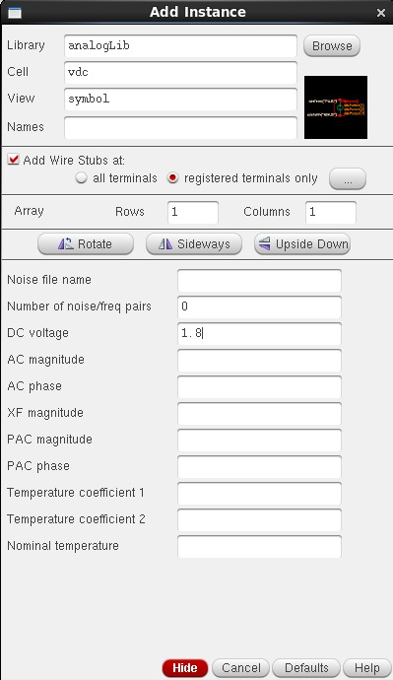
Figure-3.4. Add Instance window of the vdc source that sets the VDD supply to 1.8 V.

3.2 NOT gate (inverter)
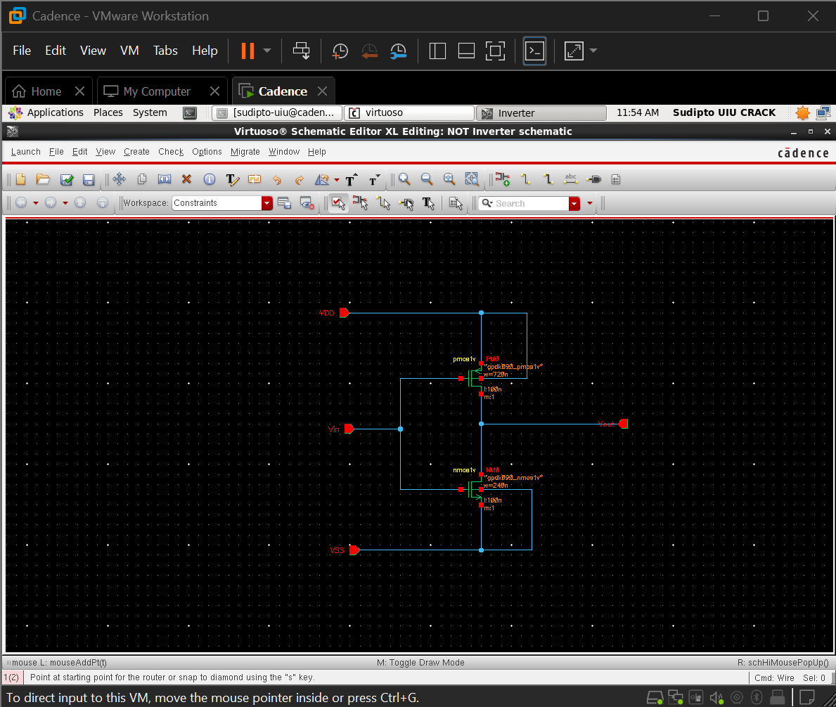
Figure-3.5. Transistor-level schematic of the CMOS NOT gate: PM0 (w = 720n) as pull-up, NM0 (w = 240n) as pull-down, with Vin, Vout, VDD and VSS pins.
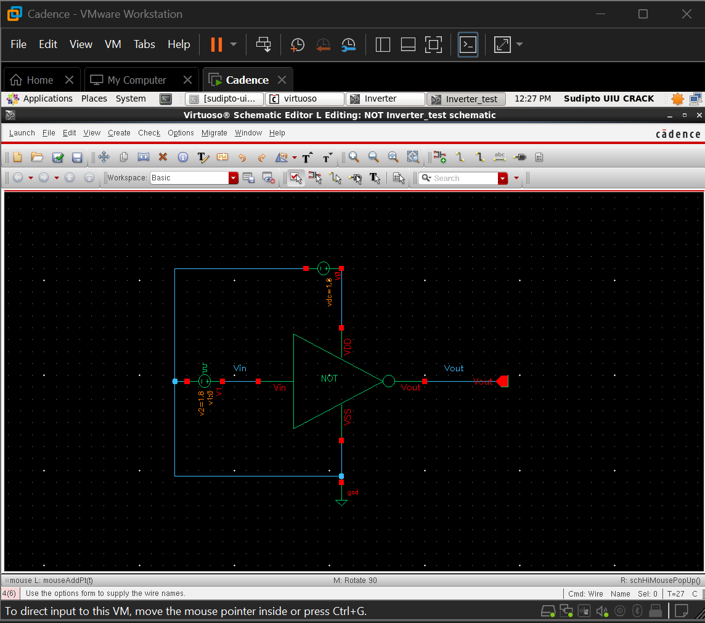
Figure-3.6. Test bench of the NOT gate showing the inverter symbol, the vpulse input source, the 1.8 V DC supply, ground and the Vin and Vout nets.
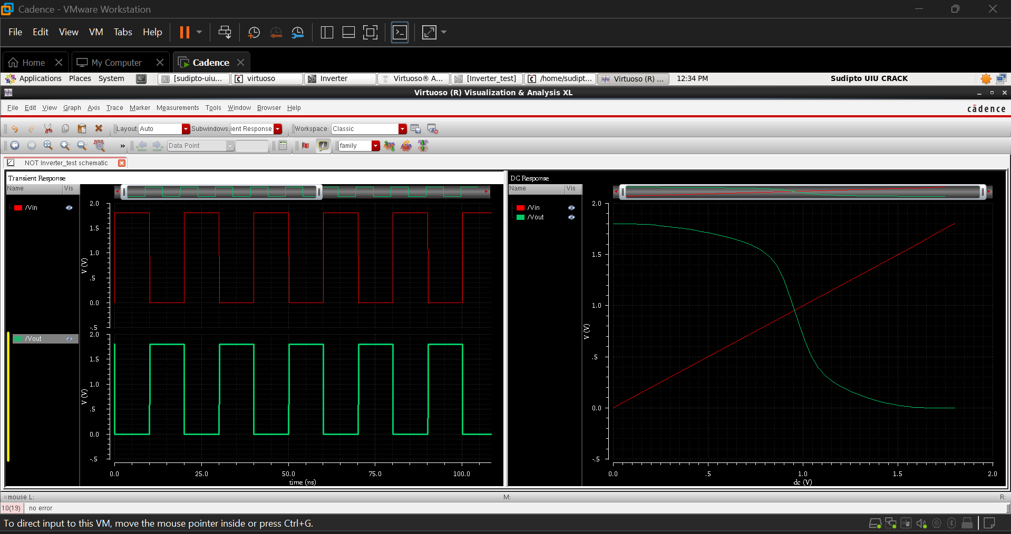
Figure-3.7. Simulation results of the NOT gate: transient response over 100 ns (left) and DC voltage transfer characteristic (right).

3.3 NAND gate
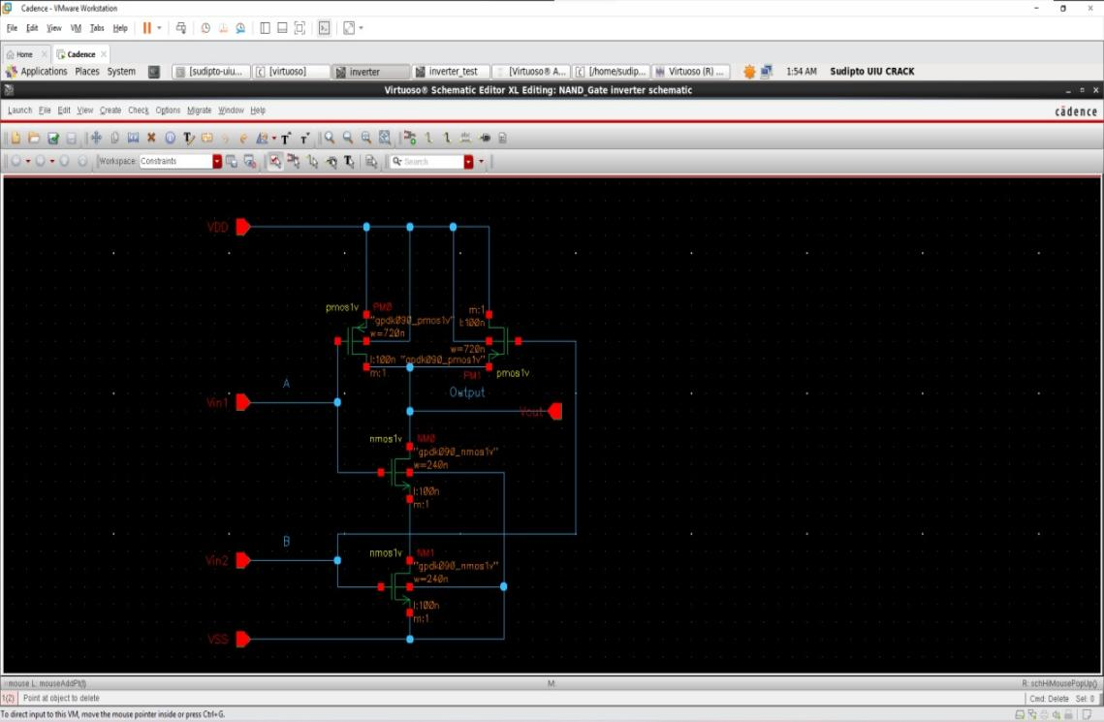
Figure-3.8. Transistor-level schematic of the CMOS NAND gate: two parallel PMOS transistors (PM0, PM1) and two series NMOS transistors (NM0, NM1).
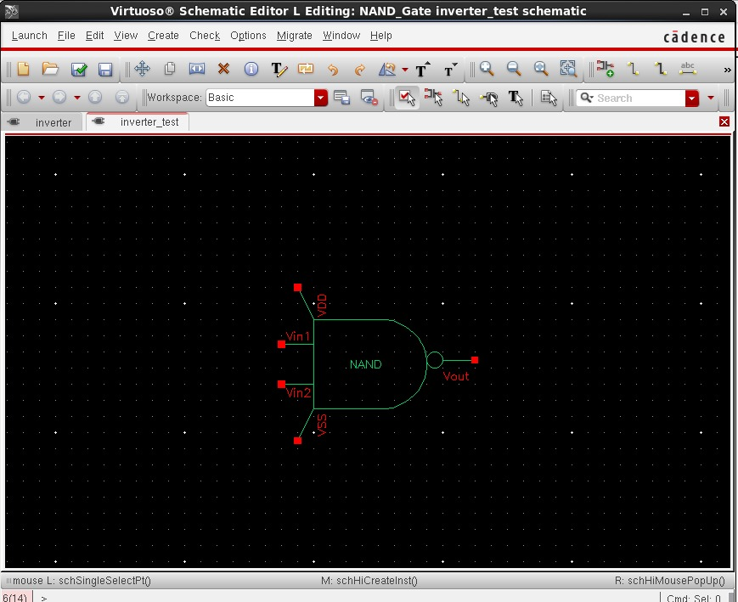  Figure-3.9. Schematic symbol of the NAND gate (AND-shaped body with output bubble) with Vin1, Vin2, Vout, VDD and VSS pins. | 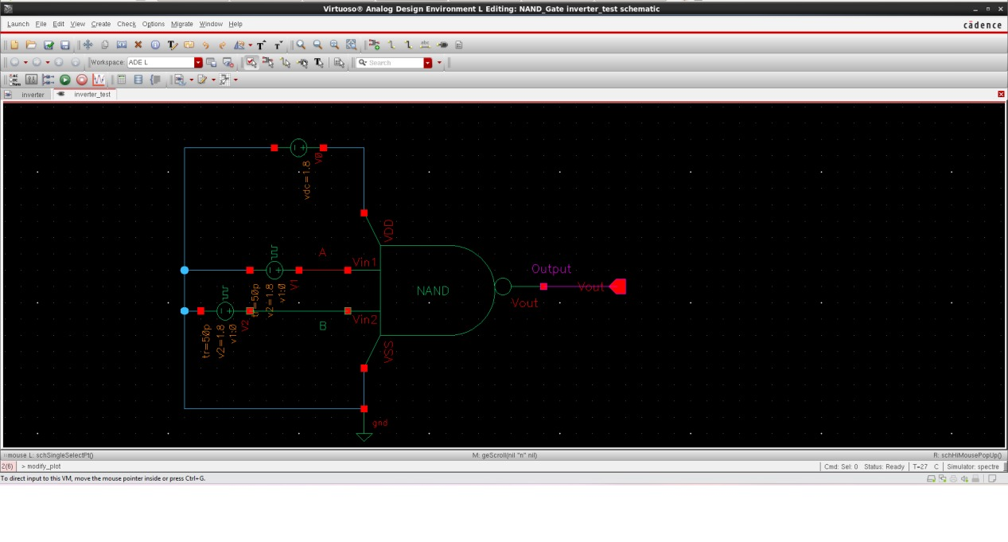  Figure-3.10. Test bench of the NAND gate with pulse sources V1 and V2, the DC supply, ground and the NAND symbol.
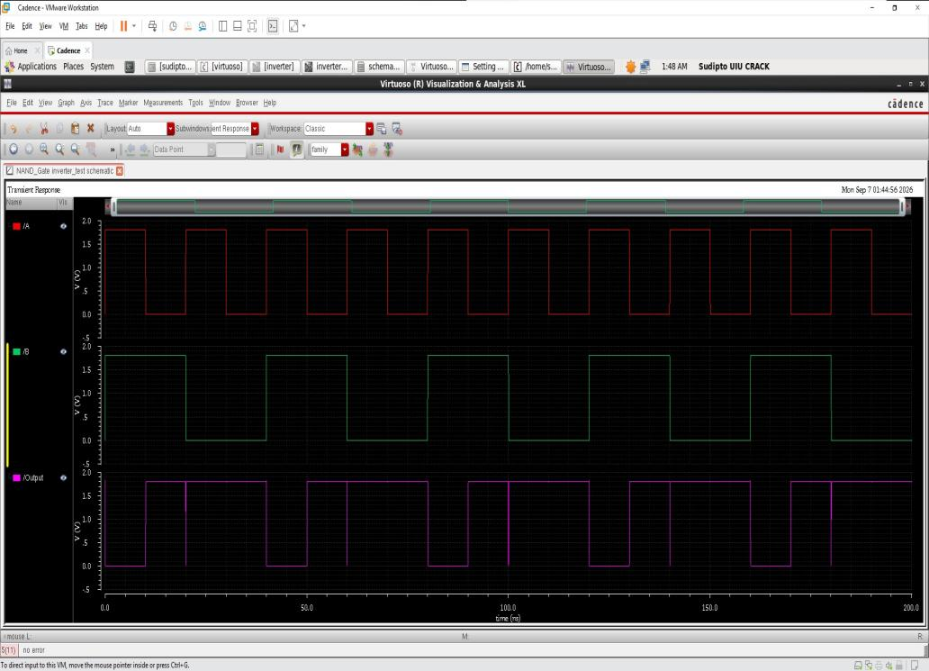
Figure-3.11. Simulation results of the NAND gate over 200 ns: inputs /A and /B and output /Output.

3.4 AND gate
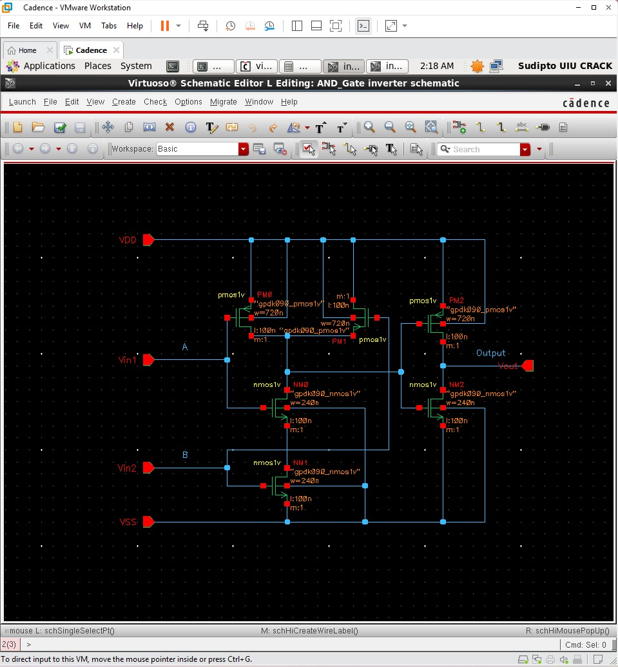
Figure-3.12. Transistor-level schematic of the CMOS AND gate: NAND stage (PM0, PM1, NM0, NM1) followed by an inverter stage (PM2, NM2).
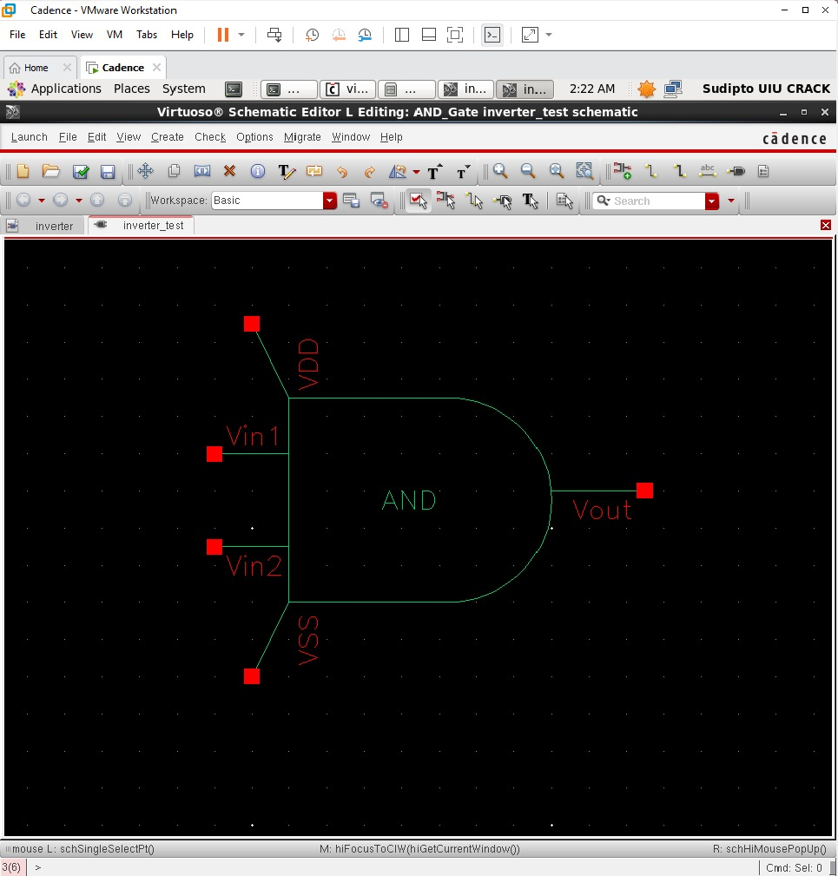  Figure-3.13. Schematic symbol of the AND gate (AND-shaped body without output bubble). | 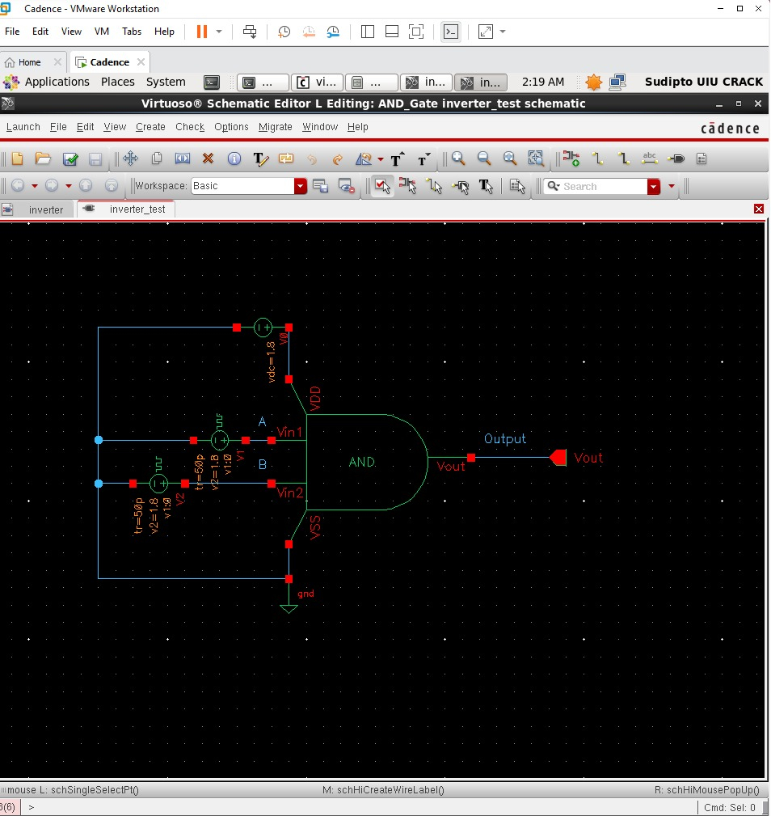  Figure-3.14. Test bench of the AND gate with pulse sources V1 and V2, the DC supply, ground and the AND symbol.
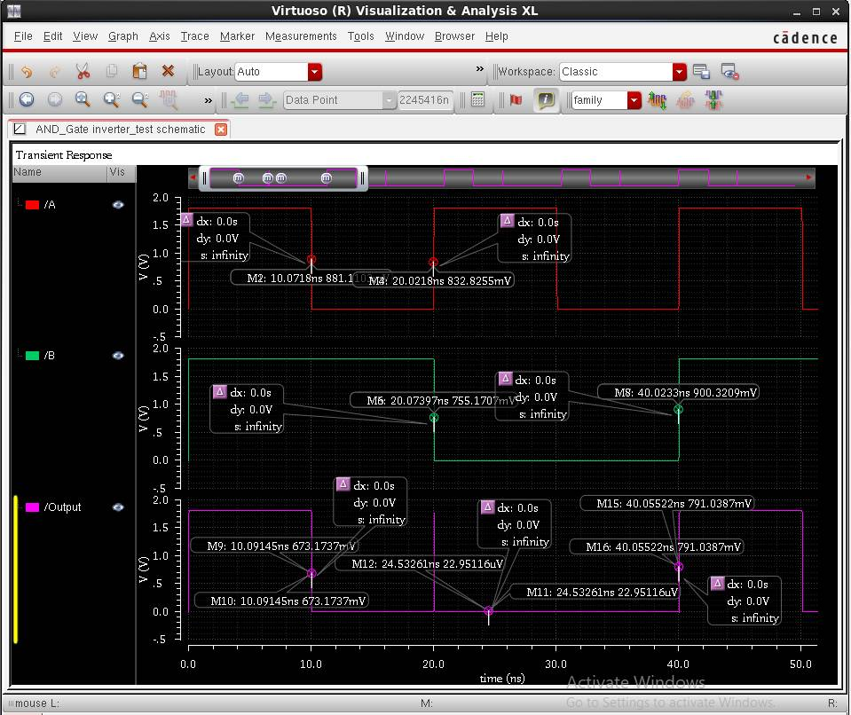
Figure-3.15. Simulation results of the AND gate over 0 to 50 ns: inputs /A and /B and output /Output on one time axis, with the calculator markers used for the delay readout (M2 and M9: A falling and the output falling at 10 ns; M8 and M15: B rising and the output rising at 40 ns; M4 and M6: A rising and B falling at 20 ns).

3.5 NOR gate
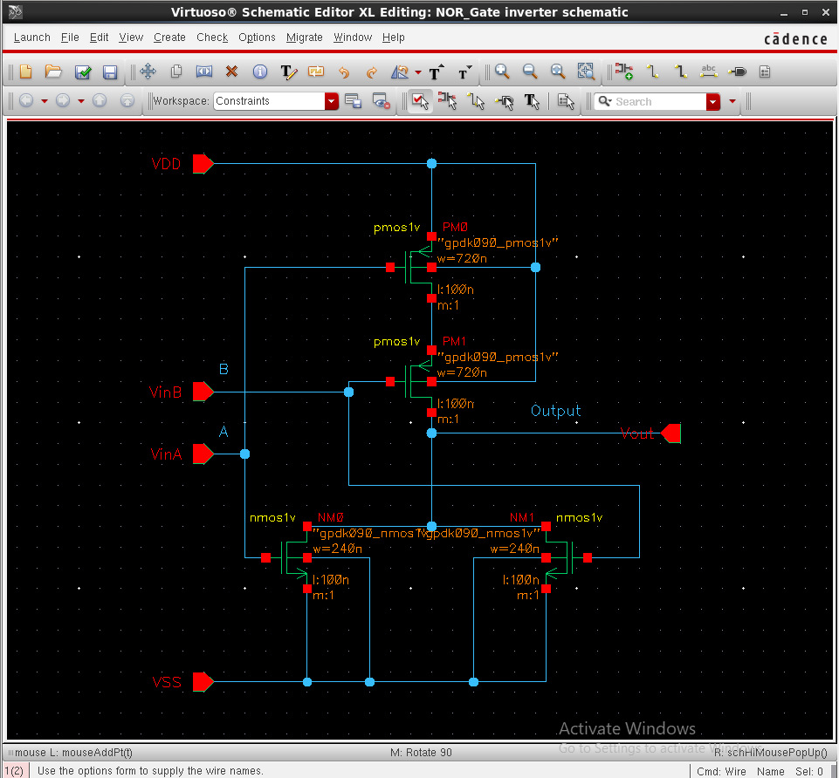
Figure-3.16. Transistor-level schematic of the CMOS NOR gate: two series PMOS transistors (PM0, PM1) and two parallel NMOS transistors (NM0, NM1).
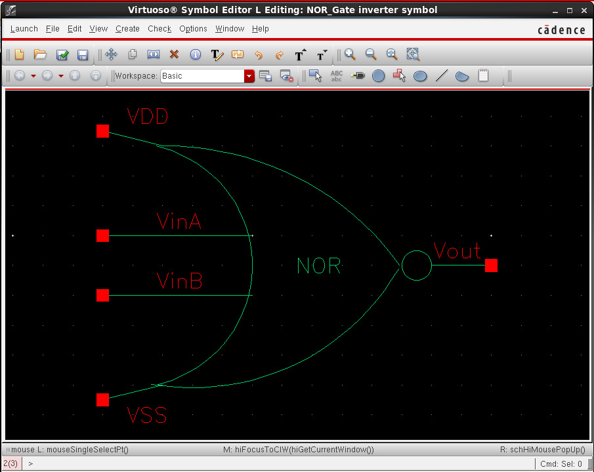  Figure-3.17. Schematic symbol of the NOR gate (OR-shaped body with output bubble) with VinA, VinB, Vout, VDD and VSS pins. | 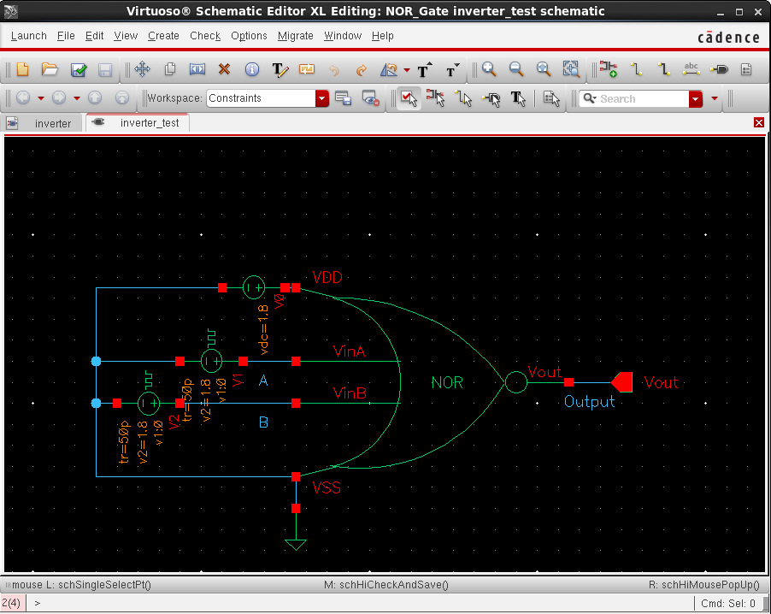  Figure-3.18. Test bench of the NOR gate with pulse sources V1 and V2, the DC supply V0, ground and the NOR symbol.
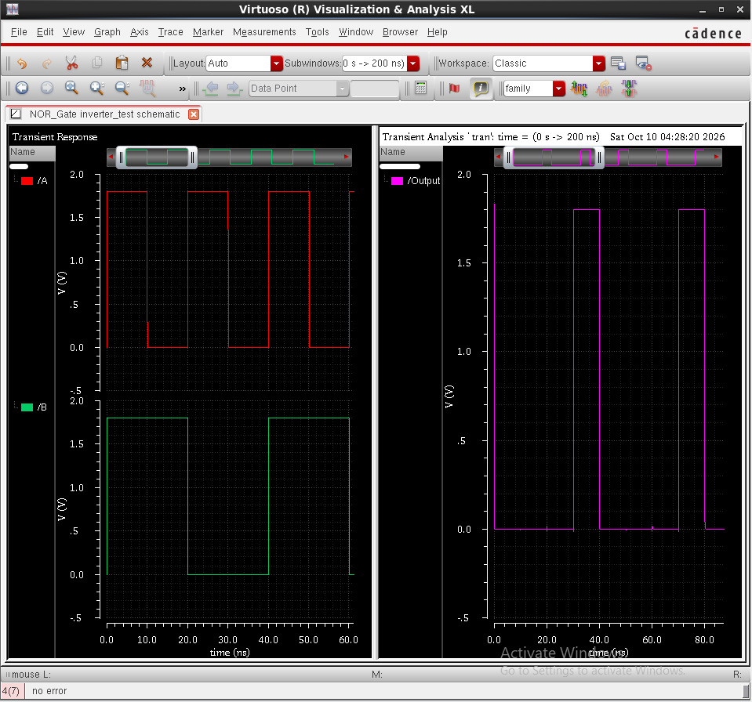
Figure-3.19. Simulation results of the NOR gate: inputs A and B (left, 0 to 60 ns) and output /Output (right, 0 to about 90 ns).

3.6 OR gate
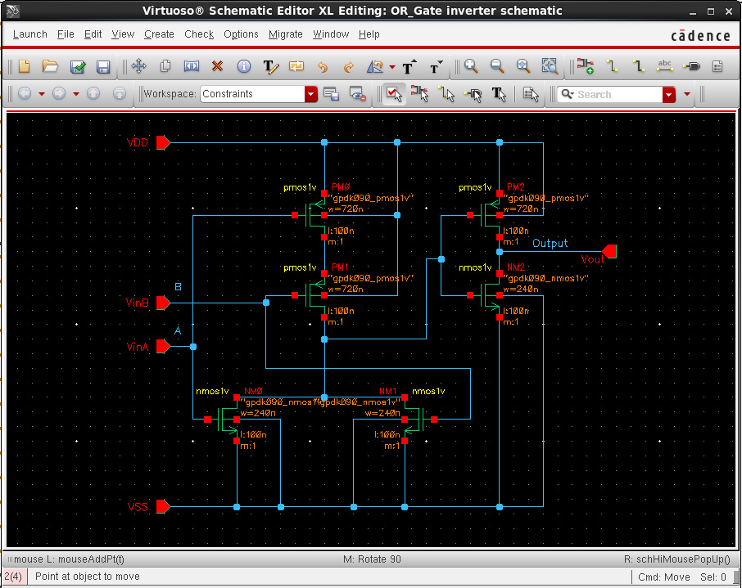
Figure-3.20. Transistor-level schematic of the CMOS OR gate: NOR stage (PM0, PM1, NM0, NM1) followed by an inverter stage (PM2, NM2).
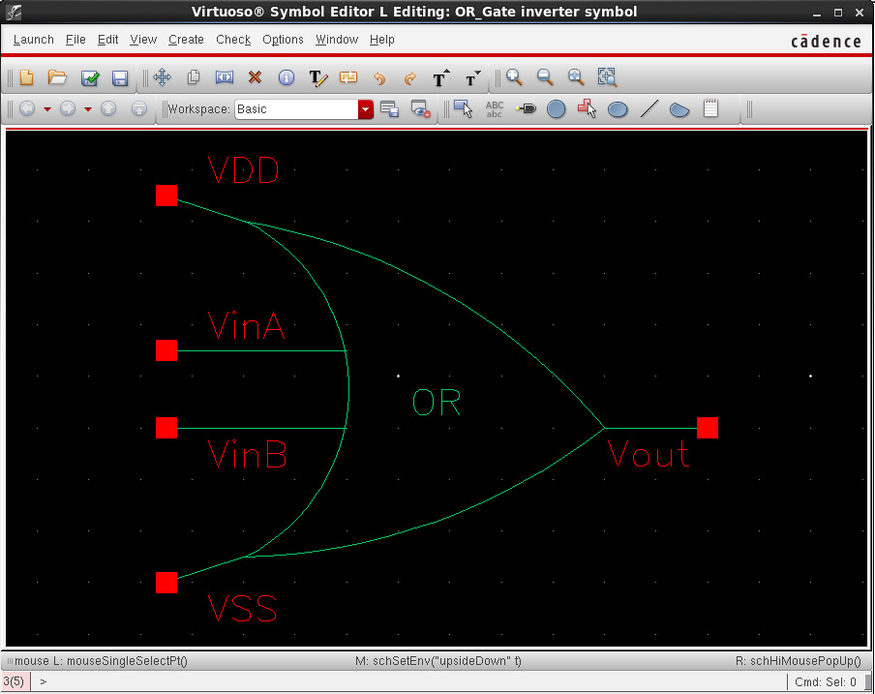  Figure-3.21. Schematic symbol of the OR gate (OR-shaped body without output bubble). | 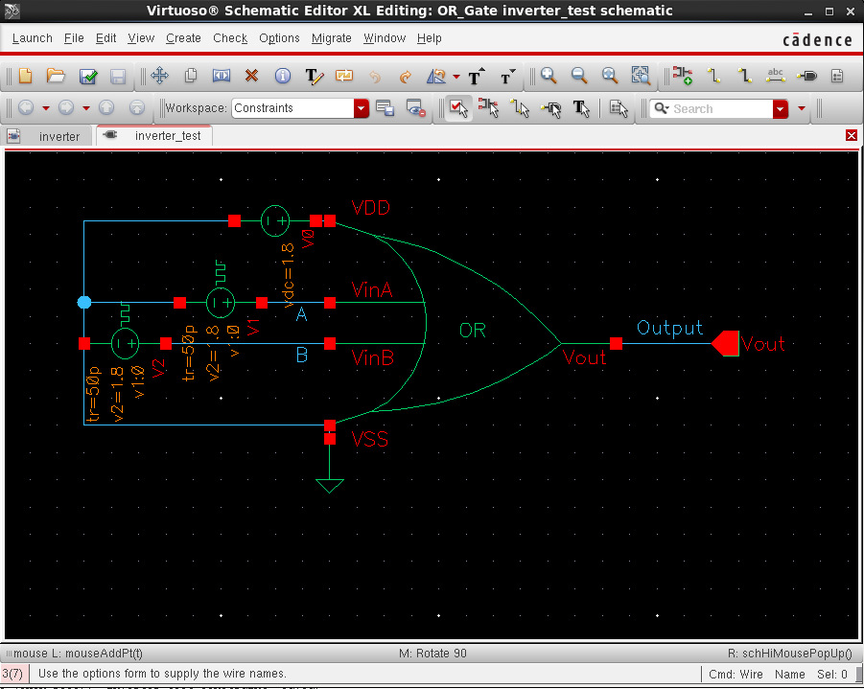  Figure-3.22. Test bench of the OR gate with pulse sources V1 and V2, the DC supply V0, ground and the OR symbol.
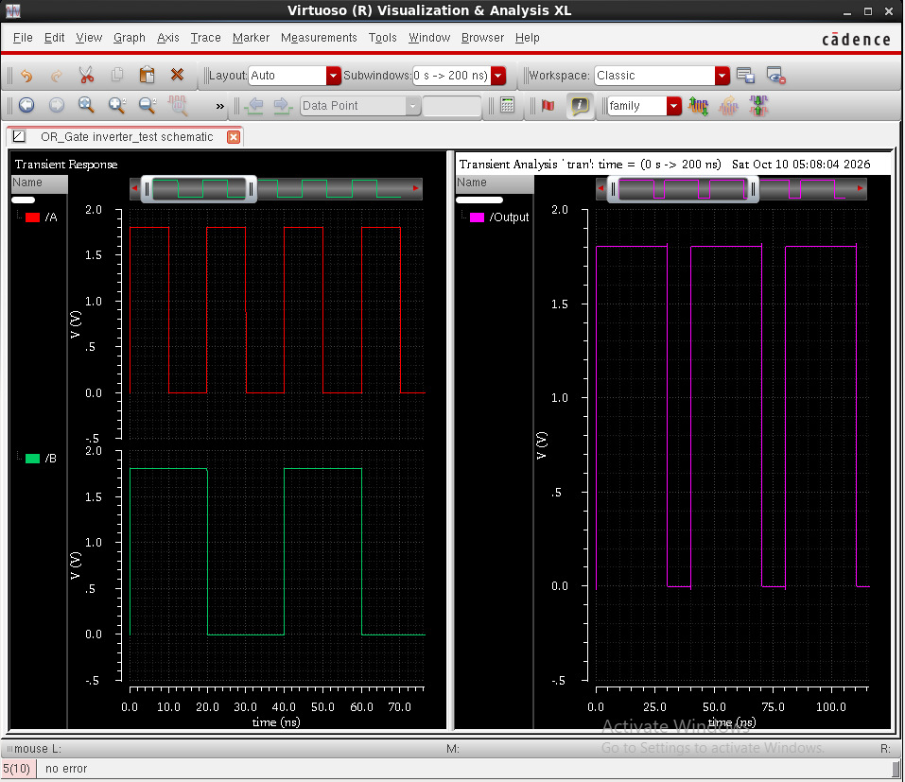
Figure-3.23. Simulation results of the OR gate: inputs A and B (left, 0 to about 75 ns) and output /Output (right, 0 to about 110 ns).

3.7 XOR gate
The XOR figures show the final, hierarchical design. The top-level schematic instantiates the library cells directly: two NOT cells, two AND cells and one OR cell.
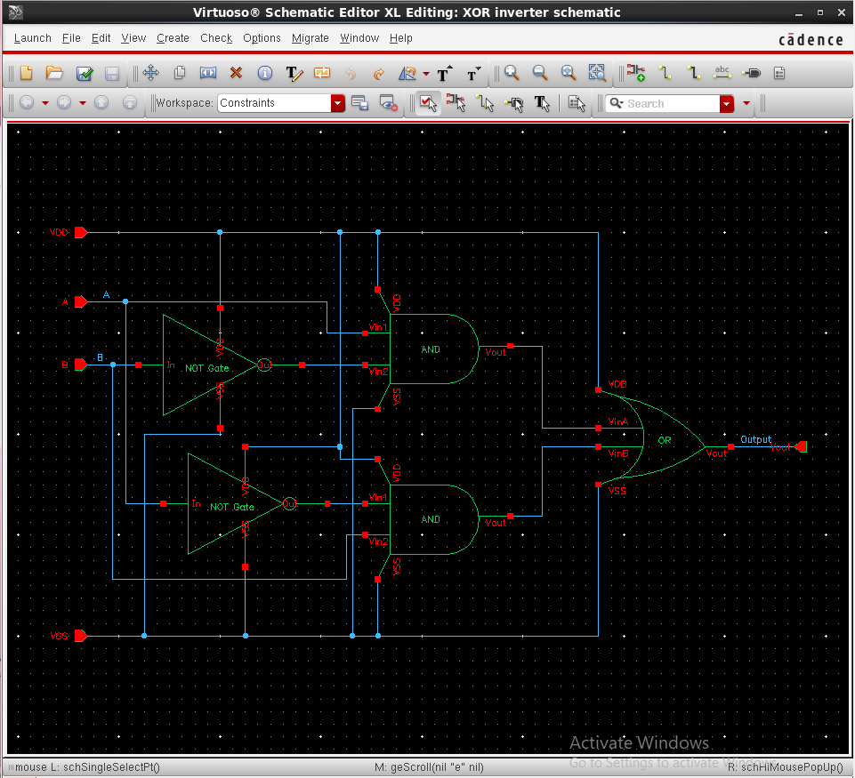
Figure-3.24. Final hierarchical schematic of the XOR gate (22 transistors): two NOT cells generate A′ and B′, two AND cells form A·B′ and A′·B, and one OR cell combines the two product terms into the Output pin.
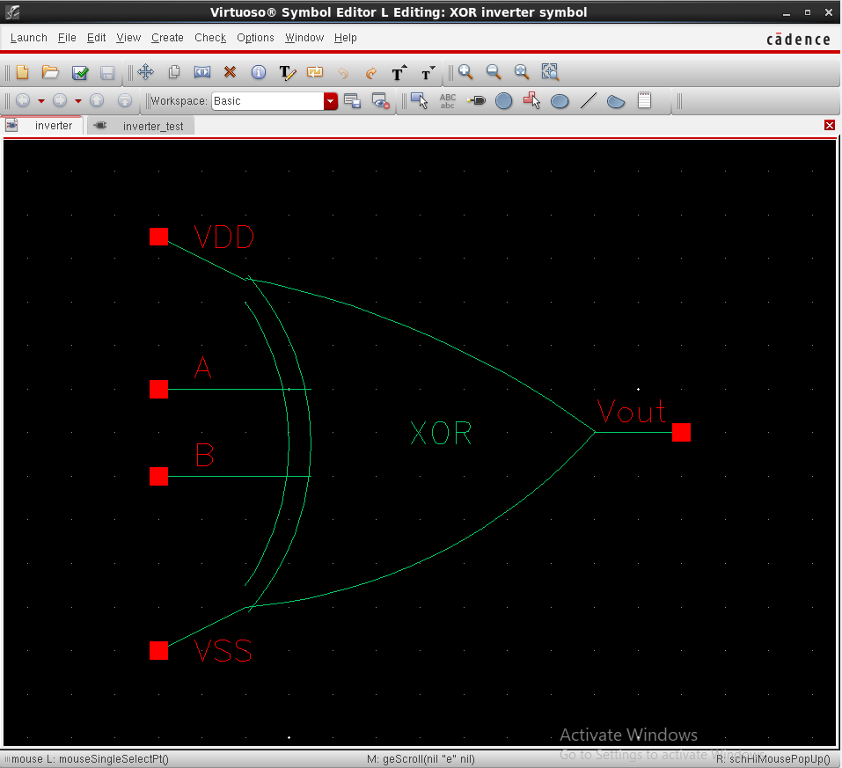  Figure-3.25. Schematic symbol of the XOR gate (OR-shaped body with an extra curved line on the input side) with VDD, A, B, VSS and Vout pins. | 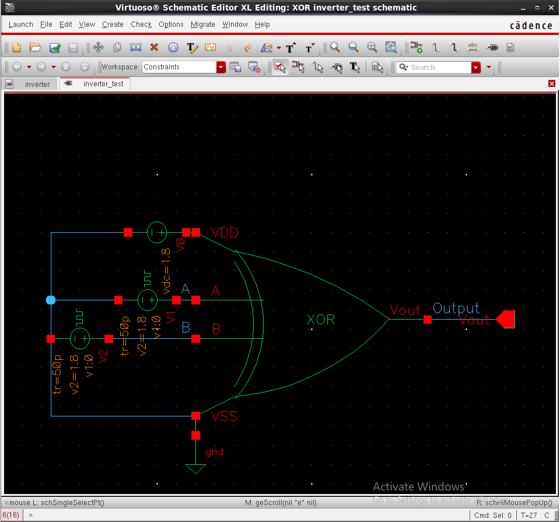  Figure-3.26. Test bench of the XOR gate with pulse sources V1 and V2, the DC supply, ground and the XOR symbol, with the A, B and Output nets labelled.
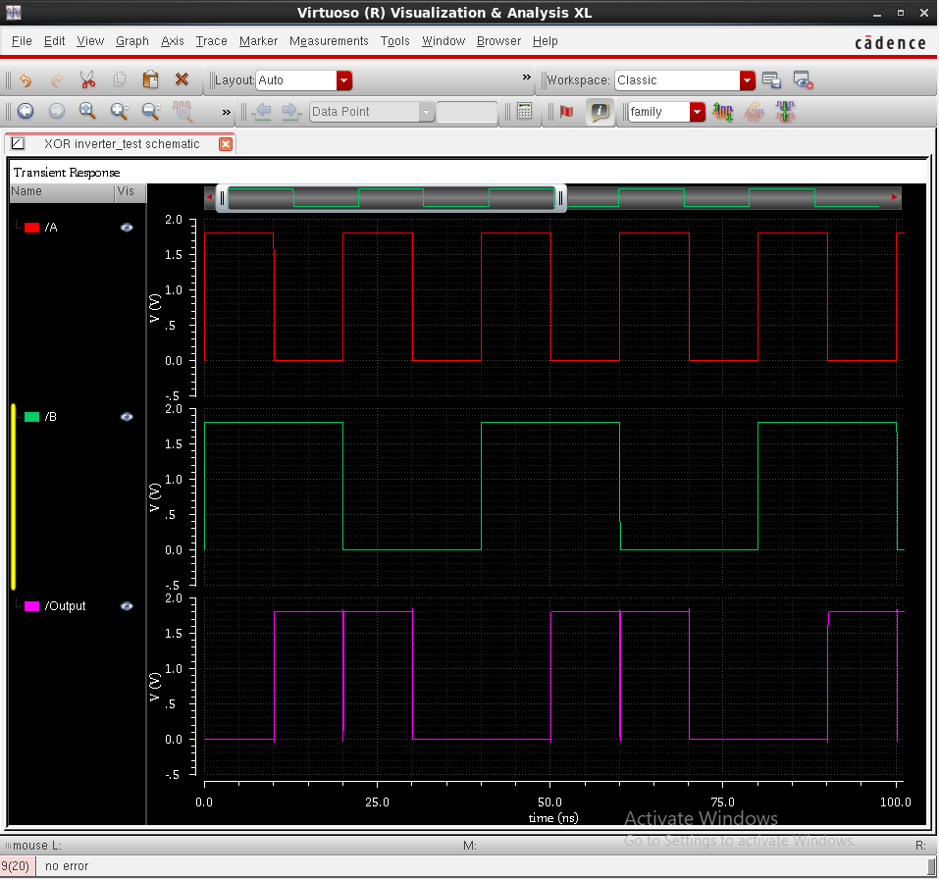
Figure-3.27. Simulation results of the XOR gate over 0 to 100 ns: inputs /A and /B and output /Output on one time axis.

4. Results and Comparison

4.1 Truth-table verification of each gate
The output of each gate was compared with its ideal truth table, interval by interval, using the waveforms of Section 3. The observed behaviour is summarised in Table-4.1.
Gate | Observed output behaviour (from the waveforms) | Waveform figure | Truth table
NOT | Vout is about 1.8 V while Vin is LOW and about 0 V while Vin is HIGH in every cycle of the 100 ns shown. The VTC falls smoothly from 1.8 V to 0 V, with the switching point close to VDD/2 (about 0.9 V). | Figure-3.7 | Verified
NAND | Output is LOW only when A = B = 1 (0–10, 40–50, 80–90, 120–130, 160–170 ns) and HIGH in all other intervals. Narrow spikes appear at 20, 60, 100, 140 and 180 ns. | Figure-3.11 | Verified
AND | Output is HIGH only when A = B = 1 (0–10 ns and 40–50 ns) and LOW for (0,1), (1,0) and (0,0) (10–40 ns). A narrow spike appears at 20 ns. | Figure-3.15 | Verified
NOR | Output is LOW for (1,1), (0,1) and (1,0) and HIGH only when A = B = 0 (30–40 ns and 70–80 ns). | Figure-3.19 | Verified
OR | Output is HIGH for (1,1), (0,1) and (1,0) and LOW only when A = B = 0 (30–40 ns and 70–80 ns). | Figure-3.23 | Verified
XOR | Output is LOW for (1,1) (0–10, 40–50, 80–90 ns) and for (0,0) (30–40, 70–80 ns), so it is LOW from 30 to 50 ns and from 70 to 90 ns, and HIGH for (0,1) and (1,0) (10–30, 50–70, 90–100 ns). Narrow dips appear at 20 ns and 60 ns. | Figure-3.27 | Verified
Table-4.1. Truth-table verification result for each gate.
Table-4.2 puts the observed outputs of the five two-input gates side by side for every input combination. For all five gates the observed output equals the ideal output in all four rows. The XOR output differs from the NAND output only in the (0,0) row, which is the row that distinguishes the two functions.
A | B | NAND | AND | NOR | OR | XOR
1 | 1 | 0 | 1 | 0 | 1 | 0
0 | 1 | 1 | 0 | 0 | 1 | 1
1 | 0 | 1 | 0 | 0 | 1 | 1
0 | 0 | 1 | 0 | 1 | 0 | 0
Table-4.2. Observed output logic level of the five two-input gates for each input combination; all agree with the ideal truth tables.

4.2 Comparison of the six designs
Gate | Boolean function | Transistors (P + N) | Stages (in series) | Series stack | Total width (nm) | Relative to NOT
NOT | Y = A′ | 2 (1 + 1) | 1 | None | 960 | 1×
NAND | Y = (A·B)′ | 4 (2 + 2) | 1 | NMOS (2) | 1920 | 2×
NOR | Y = (A + B)′ | 4 (2 + 2) | 1 | PMOS (2) | 1920 | 2×
AND | Y = A·B | 6 (3 + 3) | 2 | NMOS (2) | 2880 | 3×
OR | Y = A + B | 6 (3 + 3) | 2 | PMOS (2) | 2880 | 3×
XOR | Y = A·B′ + A′·B | 22 (11 + 11) | 8 stages (2 NOT, 2 AND, 1 OR cells); 4 to 5 on a signal path | NMOS (2) in NAND stages and PMOS (2) in NOR stage | 10560 | 11×
Table-4.3. Structural comparison of the six cells. Total width is the sum of all transistor widths (each PMOS/NMOS pair adds 720 + 240 = 960 nm) and is used here only as a first-order area indicator.
The structural comparison shows how quickly complexity grows. NAND and NOR need twice the transistor width of the inverter, AND and OR need three times because they add an inverter stage, and the XOR gate built from NOT, AND and OR cells needs eleven times. The XOR cell is also the only one in which a signal passes through four to five cells in series. NAND and NOR have the same transistor count but opposite stacks: NAND has its stack in the NMOS pull-down, NOR in the weaker PMOS pull-up.

4.3 Comparison of the simulation setups and waveforms
Gate | Input sources | Transient stop time | Net names in the test bench | Notable feature of the screenshot
NOT | One pulse source (20 ns / 10 ns) | 200 ns (100 ns plotted) | Vin, Vout | Also has a DC sweep (0–1.8 V) and VTC plot
NAND | Two (20/10 ns and 40/20 ns) | 200 ns | Vin1, Vin2, Vout (plotted /A, /B, /Output) | Full 200 ns on one time axis; narrow spikes at 20 ns, 60 ns and so on
AND | Two (20/10 ns and 40/20 ns) | 200 ns | Vin1, Vin2, Vout | Inputs and output over 50 ns on one time axis, with delay markers; spike at 20 ns
NOR | Two (20/10 ns and 40/20 ns) | 200 ns | A, B, Output | Inputs over 60 ns; output over about 90 ns
OR | Two (20/10 ns and 40/20 ns) | 200 ns | A, B, Output | Inputs over about 75 ns; output over about 110 ns
XOR | Two (20/10 ns and 40/20 ns) | 200 ns | A, B, Output | Inputs and output over 100 ns on one time axis; dips at 20 ns and 60 ns
Table-4.4. Comparison of the test benches and waveform screenshots of the six experiments.
Three differences between the waveform screenshots are worth noting. First, the NOT experiment is the only one with a DC analysis, which shows that the switching threshold lies close to VDD/2, in agreement with the 3:1 sizing. Second, the output level at t = 0, while both inputs are still at their initial 0 V, differs between gates: the NOR output starts near 1.8 V, while the OR and XOR outputs start at 0 V, each correct for (0,0). Third, a narrow spike is visible on the output at 20 ns in the NAND, AND and XOR plots, and again at 60 ns, 100 ns and so on in the NAND and XOR plots (the XOR plot ends at 100 ns). These spikes are explained by the stimulus, not by the gates. In the pulse sources, A rises during 20.00 to 20.05 ns, but B, whose pulse width ends 50 ps later, only starts to fall at 20.05 ns, so both inputs are at about 1.8 V for roughly 50 ps and the circuit briefly sees (A, B) = (1,1) between (0,1) and (1,0). The markers in Figure-3.15 show this overlap (A at 833 mV at 20.02 ns, B still falling through 755 mV at 20.07 ns). The correct response to (1,1) is a short HIGH pulse for AND, a short LOW dip for NAND and a short LOW dip for XOR, which is what the plots show. The NOR gate gives LOW and the OR gate gives HIGH for (0,1), (1,0) and (1,1) alike, so the overlap is invisible in their outputs and they show no spike. The depth of each spike depends on how the gate delay compares with the 50 ps overlap. Spectre also reports trapezoidal ringing with method = traponly in all six logs, which is a separate notice that does not need to be invoked to explain these spikes, but method = trap (or gear) is still recommended for the delay run.

4.4 Propagation delay
Table-4.5 lists the propagation delays of the six gates as read in the waveform calculator, using the 50 % definition of Section 2.5. The average is tp = (tpHL + tpLH) / 2, and the six averages are compared in Figure-4.1. The expected-rank column repeats the topology-based expectation made before the measurement: every added stage and every series stack should increase the delay.
Gate | Cells on the critical path | tpHL (ps) | tpLH (ps) | tp (ps) | Measured rank (1 = fastest) | Expected rank before measurement
NOT | 1 (inverter) | 6.3 | 32.0 | 19.15 | 1 | 1
NAND | 1 (NAND) | 34.4 | 28.5 | 31.45 | 3 | 2 to 3
AND | 2 (NAND + inverter) | 19.7 | 31.9 | 25.8 | 2 | 4 to 5
NOR | 1 (NOR) | 79.4 | 24.4 | 51.9 | 4 | 2 to 3
OR | 2 (NOR + inverter) | 98.9 | 9.1 | 54.0 | 5 | 4 to 5
XOR | 4 to 5 (A path to B path) | 128.1 | 50.5 | 89.3 | 6 | 6
Table-4.5. Propagation-delay comparison. The AND values are assigned from the markers of Figure-3.15; the tpHL and tpLH assignment of the other gates is as supplied and has not been checked against markers. The yellow cell (OR tpLH) fails a consistency check (see text) and should be re-measured.
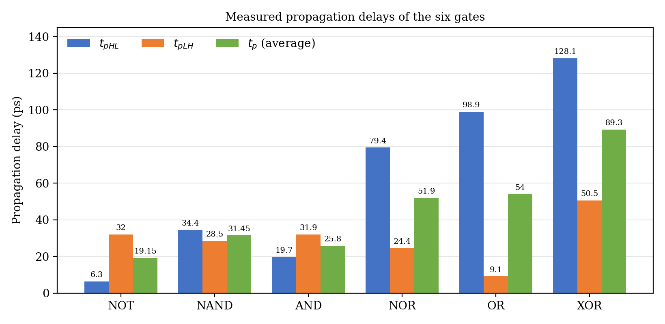
Figure-4.1. Measured tpHL, tpLH and average propagation delay of the six gates.
Ranked by average delay, the gates fall into the order NOT (19.15 ps), AND (25.8 ps), NAND (31.45 ps), NOR (51.9 ps), OR (54.0 ps) and XOR (89.3 ps). The inverter is fastest and the XOR gate slowest, about 4.7 times the inverter, as the stage count predicts. NOR and OR are close to each other and roughly 1.7 times the NAND, which agrees with the weak series PMOS stack that both contain, whereas the two-stage AND gate is not slower than the single-stage NAND gate. For AND the edge pair is documented by the markers of Figure-3.15, which give tpHL = 19.7 ps and tpLH = 31.9 ps. For the other gates the readouts show NAND with tpHL = 34.4 ps and tpLH = 28.5 ps, NOR with 79.4 ps and 24.4 ps, OR with 98.9 ps and 9.1 ps, NOT with 6.3 ps and 32.0 ps, and XOR with 128.1 ps and 50.5 ps. For a NOR gate with its series stack in the PMOS network the slower edge would be expected to be the rising one, so the NOR assignment of tpHL and tpLH should be checked against markers on its waveform in the same way as for AND. The NOT test bench also uses a source with no specified edge time, so its values may not be directly comparable.
Two consistency checks can be made on the cascaded gates, because a two-stage gate should not be faster than its own first stage for the same input event. The OR output rises after the NOR stage output falls, so the OR tpLH should be at least the NOR output-fall delay; the OR tpLH of 9.1 ps is below both NOR values (79.4 ps and 24.4 ps) and below the inverter tpLH of 32.0 ps, so it still looks too small and should be re-measured. The OR tpHL of 98.9 ps, in contrast, is consistent with a slow NOR rising edge followed by an inverter. For AND, the readouts (19.7 ps and 31.9 ps) are each below the corresponding NAND values (28.5 ps and 34.4 ps), which suggests that the AND and NAND readouts were taken at different input events, for example a single-input change for one gate and a two-input change for the other, so these two gates should not be compared too finely.

4.5 Cross-check with the Spectre log files
The Spectre log of each gate lists the circuit inventory, which can be compared with the schematic. Table-4.6 does this: the number of non-ground nodes was counted from each topology (supply, inputs, internal series-stack nodes, stage outputs and output), and the device counts are those of Table-4.3.
Gate | Nodes expected | Nodes in log | MOS expected | bsim3v3 in log | Voltage sources | Accepted tran steps
NOT | 3 | 3 | 2 | 2 | 2 | 663
NAND | 5 | 5 | 4 | 4 | 3 | 758
AND | 6 | 6 | 6 | 6 | 3 | 831
NOR | 5 | 5 | 4 | 4 | 3 | 677
OR | 6 | 6 | 6 | 6 | 3 | 831
XOR | 14 | 14 | 22 | 22 | 3 | 1171
Table-4.6. Netlist inventory reported by Spectre for each test bench compared with the expected topology.
Every netlist has the expected number of devices and nodes, including the final XOR gate with 22 transistors and 14 nodes, so no device is missing and no net is merged. The XOR netlist instantiates two NOT cells (producing the complemented inputs), two AND cells (net15 = A·B′ and net14 = A′·B) and one OR cell (Output), and a switch-level evaluation of this netlist outside Cadence returns the XOR truth table for all four input combinations, in agreement with the simulated waveform. The accepted transient step count rises from 663 for the inverter to 1171 for the XOR gate, in line with the growing amount of switching activity, but it depends on the solver and should be read only as a rough indicator.
The NOR netlist (input.scs) was also read directly and matches the schematic: PM0 connects VDD to an internal node under the control of A, PM1 connects that node to the output under the control of B, and NM0 and NM1 connect the output to VSS in parallel, with W = 720 nm for PMOS, 240 nm for NMOS and L = 100 nm.
Two other points appear in the logs. First, the five two-input test benches report ERROR (SFE-421), Undefined parameter name dc, for the DC analysis; the transient analysis had already completed, so the waveforms are valid, and the NOR netlist shows the cause: it contains the statement dc dc param=dc start=0 stop=1.8, which sweeps a design variable named dc that does not exist (the NOT run swept the source parameter V1:dc instead). The DC analysis should therefore be switched off in those test benches (only the NOT log shows a successful DC sweep, of V1:dc from 0 V to 1.8 V). Second, every run prints the warning that the Rds of PM0 (about 11 µΩ) is below the model limit and is set to 0, which is a device-model message with no effect on the results.

5. Discussion
The five working cells agree with the theory of complementary CMOS. Each one produced rail-to-rail outputs (about 0 V and 1.8 V) that follow the ideal truth table in every interval that was plotted, and in none of them were the pull-up and pull-down networks ON at the same time in a static state, so the static power is ideally zero. Building AND from NAND plus an inverter and OR from NOR plus an inverter worked as predicted: the extra stage restores the non-inverting function and sharpens the edges, at the price of one more stage in the signal path and 50 % more transistor width than the inverting gate it is built on.
Keeping one device size for the whole library made the comparison clean, but it also means that the NAND and NOR stacks, and therefore the XOR gate, are not speed-optimised. In a production library the two series transistors would be widened, for instance doubling the NMOS width in NAND and the PMOS width in NOR, to bring their worst-case drive strength close to that of the inverter.
The XOR gate shows the value of building a library of verified cells. The first implementation, a flat 22-transistor schematic, reproduced three of the four input combinations and gave HIGH instead of LOW for (0,0), so its output matched that of a NAND gate; the cause in that version was not isolated. The final XOR instead instantiates the verified NOT, AND and OR cells (two NOT, two AND and one OR). Its simulation matches the XOR truth table for all four combinations, including (0,0) at 30 to 40 ns and 70 to 80 ns, and it keeps the same 22 transistors and device sizes as the flat version, so nothing was lost in area. The two narrow dips at 20 ns and 60 ns are not a fault of the gate: the stimulus passes briefly through (1,1) between (0,1) and (1,0) (Section 4.3), and the XOR output correctly goes LOW for that short time.
The delay results show that, without an external load, the gate delays are only tens of picoseconds and depend strongly on the edge used, so a stage-count rule alone does not rank the cells exactly: the inverter is fastest and the XOR gate slowest, NOR and OR (both containing the PMOS stack) are slower than NAND and AND, but the two-stage AND gate is not slower than the single-stage NAND gate. The OR tpLH of 9.1 ps and the AND and NAND readouts fail simple cascade checks (Section 4.4), so they should be re-measured at the same input event.
Three limitations should be kept in mind. All test benches have an unloaded output, so every delay is an intrinsic delay; adding a load capacitor equal to a few inverter inputs would give a more realistic figure. The delay readouts come from runs with a 4 ns maximum step and trapezoidal integration, so values of a few picoseconds, such as the NOT tpHL of 6.3 ps, are close to what that setup can resolve and should be confirmed with a maximum step of about 10 ps. And the edge pair is documented only for the AND gate, so the asymmetric tpHL and tpLH values of the other gates cannot yet be fully interpreted.

6. Conclusion
In this project a six-cell CMOS standard cell library (NOT, NAND, AND, NOR, OR and XOR) was designed at the transistor level in Cadence Virtuoso using the gpdk090 library, with a schematic, a symbol and a test bench for every cell. All cells were built with the same device sizes (PMOS 720 nm, NMOS 240 nm, L = 100 nm) so that they could be compared directly. The main results are:
- All six gates were verified for every input combination by Spectre transient simulation in ADE L; the NOT gate also showed a VTC with its switching threshold close to VDD/2.
- The XOR gate was first built as a flat 22-transistor schematic that gave HIGH instead of LOW for (0,0). Rebuilding it from the NOT, AND and OR cells of the library gave the correct XOR output for all four combinations, The short dips at 20 ns and 60 ns are the correct response to the brief (1,1) state in the stimulus.
- Complexity grows from 2 transistors (NOT) through 4 (NAND, NOR) and 6 (AND, OR) to 22 (XOR); the XOR gate uses eleven times the transistor width of the inverter and has the deepest signal path.
- NAND and NOR differ only in where the series stack sits (NMOS for NAND, PMOS for NOR). The measured NOR delay (51.9 ps) is about 1.7 times the NAND delay (31.45 ps), and the OR delay (54.0 ps), whose first stage is a NOR, is similar, consistent with the stack being in the weaker PMOS network; the NOR tpHL and tpLH assignment should still be checked with markers.
- Average propagation delays of 19.15 ps (NOT), 25.8 ps (AND), 31.45 ps (NAND), 51.9 ps (NOR), 54.0 ps (OR) and 89.3 ps (XOR) were measured; NOT is the fastest and XOR the slowest, about 4.7 times the inverter. The OR tpLH of 9.1 ps and the tpHL and tpLH labels of the other gates still need to be confirmed.
The project gave practical experience with the whole cell-design loop of schematic, symbol, test bench, simulation, verification and timing, and showed why a library needs both a functional check and a timing characterisation for every cell, and why reusing verified cells is safer than drawing a large gate flat. Remaining work: re-check the OR tpLH, check the tpHL and tpLH assignment of the other gates with markers as was done for AND, and confirm the picosecond-level delays with a smaller maximum step and an output load.

